# UID-3

Figma Lab 1

**BAD DESIGN:**

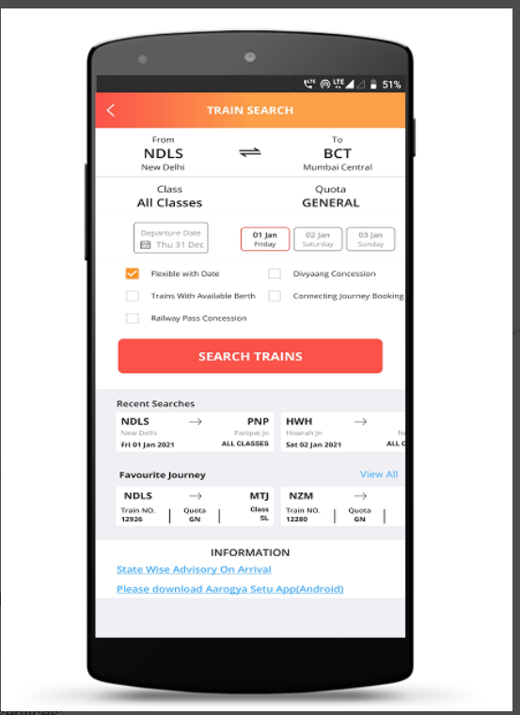

* Not simple
* Not attractive
* Too occupied
* less white space
* Too complicated
* Buttons not clear

I have taken the IRCTC app because it is used by most of the Indians, so to make it look simple will do good , this will attract more users for the app and will make it easy to use and feasible.

This design looks more complicated and not much attractive. The icons and the letters are not very legible so it may create a bad user experience therefore making the icons bigger and attractive and simple will make this design more user friendly.

**MY DESIGN:**

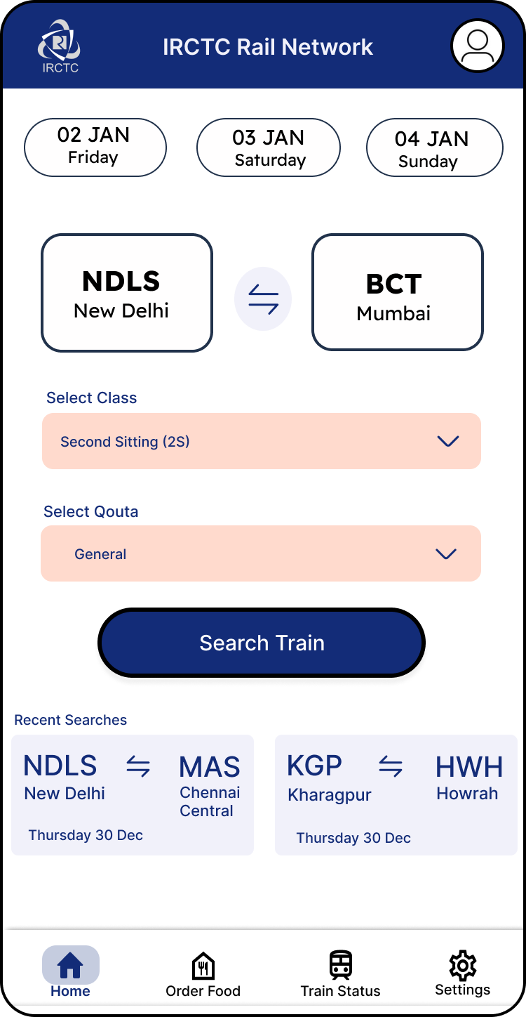•

* More simple
* Buttons are made visible.
* Extra options added
* More spacious.

Now the IRCTC page’s color has been changed and the look has been made simple.

The dropdown buttons have been added and more aligned look has been given with a proper spacing.

The date feature have been moved to the top to make the user check their booking date properly, this will avoid the mistakes in booking dates.  
After making the buttons legible the user experience will improve.

After making all the icons legible and less complicated will improve the user experience. The use of proper color shades will attract the user a lot so proper and simple colors are used.